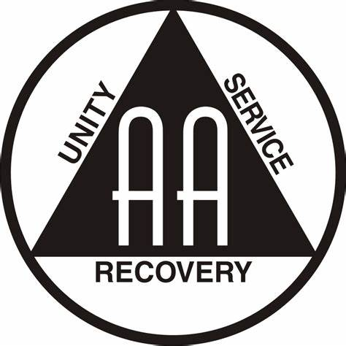

Hagerstown Area Intergroup
Presents:

2024 Gratitude Breakfast
Saturday November 2, 2024
Zion Lutheran Church*
35 W. Potomac St
Williamsport, MD 21795

Fellowship beginning at 9:00 am
Breakfast at 10:00 am
Speaker at 11:00 am

Tickets on sale for $10 until October 19, 2024
Sponsor an additional ticket for $10
Admission by ticket only.
Tickets will not be sold at the door.

For more information:
activities@hagerstownaa.org
Please text Charlie C 240 676 6178

“Gratitude unlocks the fullness of life.
It turns what we have into enough, and more.”

