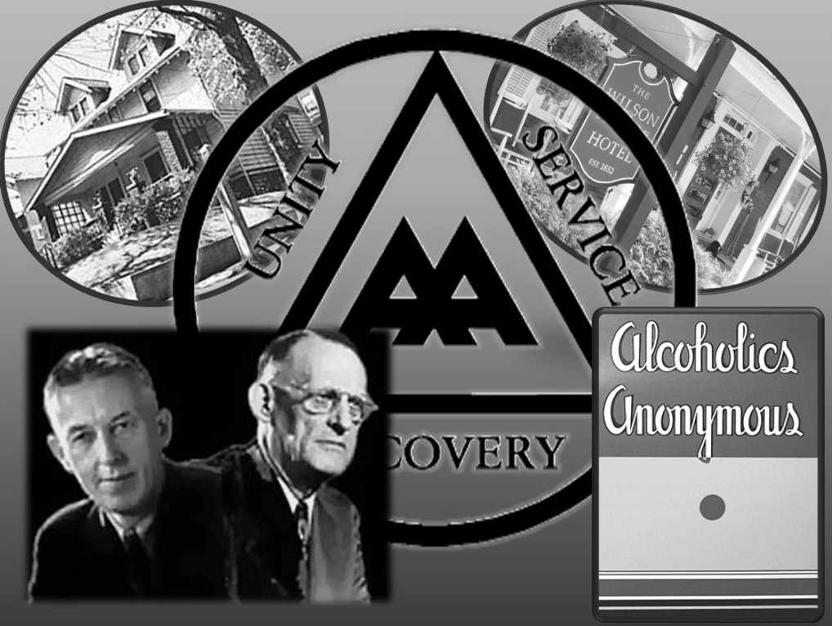
District 20 invites you to join us
Saturday, Oct. 5th 2019
1:00PM-3:00PM

For The PowerPoint Presentation
“Founding Moments”
The story of the events that led to the historic meeting of our cofounders, Bill W. and Dr. Bob.

Location:
Otterbein United Methodist Church
108 E. Franklin Street
Hagerstown, MD 21740

FREE Refreshments and Literature Drawing

